Jack Talon  bounty hunter  Novice (05 XP)  Male; Age: 35 |  | 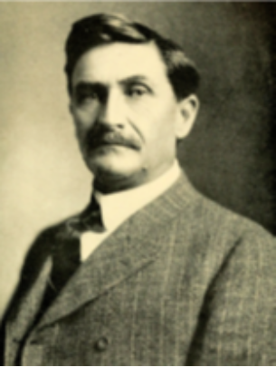
ATTRIBUTES
Agility 8 | Strength 6
Smarts 6 | Vigor 8
Spirit 6 | Wealth / Savings 6 / 0
DERIVED TRAITS
Pace 6 / d6 | Parry 5
 | Toughness 8 (2*)
Encumbrance Limit 40
SKILLS |  | COMBAT SUMMARY
Athletics 6 | Notice 6 | Unarmed Strike: Str  Knife: 3/6/12; Str+d4 [S:d4]  Colt 1911: 12/24/48; 2d6+1, RoF 1, AP 1; Shots 7 [S:d4]  Pump Action Shotgun: 12/24/48; 1-3d6, RoF 1, Shots 6 [S:d4]  Bulletproof Vest*: Armor +2, reduce ballistic damage by 2 before applying AP (torso)
Common Knowledge 6 | Persuasion 6
Driving 4 | Shooting 8
Fighting 6 | Stealth 6
Intimidation 4
HINDRANCES |  | DEFINING INTERESTS
*Victim: any time the GM decides to choose a target randomly you’re probably it; any extra adversaries “left over” when piling onto the party typically go after you  Loyal: will never leave a comrade behind and would give their life for their friends  Superstitious (Lucky coin): if the focus is lost or disturbed all Trait rolls are made at -1 |  | Law, Psychology, ???
 |  | GEAR
Carried: Backpack, brass knuckles, clothes, flashlight, binoculars, lock picks, handcuffs
Not Carried: Bulletproof vest, pump action 12 gauge shotgun

EDGES
Alertness: add +2 to Notice rolls
Luck: draw one extra Benny at the beginning of each game session

ADVANCEMENT SUMMARY
 |  | 40 |  | 80
05 | Vigor d8 | 45 |  | 90
10 |  | 50 |  | 100
15 |  | 55
20 |  | 60
25 |  | 65
30 |  | 70
35 |  | 75

BACKGROUND
Second generation American. Joined police academy. Became cop but forced out because of false allegations of mob ties and excessive force. Became bounty hunter.

Lucky coin. Given to me by my Grandfather and has always brings luck and helps me focus.

NOTES
Languages: English (native), ???. ???

