John “Jack” Dohe  occult private investigator  Novice (05 XP)  Male; Age: 39 |  | 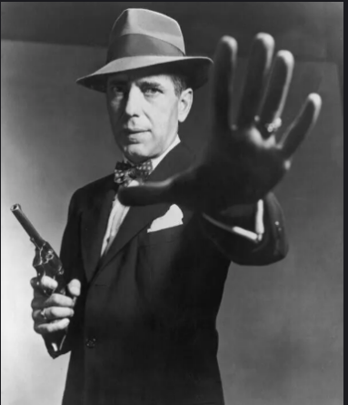
ATTRIBUTES
Agility 6 | Strength 6
Smarts 8 | Vigor 6
Spirit 6 | Wealth / Savings 6 / 0
DERIVED TRAITS
Pace 6 / d6 | Parry 5
 | Toughness 5
Encumbrance Limit 40
SKILLS |  | COMBAT SUMMARY
Athletics 4 | Research 8 | Unarmed Strike: Str  Knife: 3/6/12; Str+d4 [S:d4]  Colt 1911: 12/24/48; 2d6+1, RoF 1, AP 1; Shots 7 [S:d4]
Common Knowledge 6 | Shooting 6
Fighting 6 | Stealth 4
Notice 6 +2 | Survival 4
Occult 6 | Thievery 4
Persuasion 6
HINDRANCES |  | DEFINING INTERESTS
*Haunted Past: you are troubled by recurring dreams and intrusive flashbacks; whenever you are dealt a Clubs suit Action Card these memories flood back and all rolls that round suffer a -2 penalty.  Amorous: you are easily enamored with a pretty face; suffer a -2 penalty to resist Tests by any character with the Attractive or Very Attractive Edge  Loyal: will never leave a comrade behind and would give their life for their friends |  | American History, Law, Cars, Poker
 |  | GEAR
Carried: Expensive Suit, Colt 1911 (Large Semi-Auto;.45), Knife, .45 Ammo x50, Camera (Kodiak Brownie), Flashlight, Lockpicks, Pipe & Lighter, Engraved Flask, Heavy Overcoat
Not Carried: Beat-up Ford

EDGES
Alertness: add +2 to Notice rolls
Connections (Law Enforcement): Once per session you can request a favor, assuming they can be contacted; the favor depends on the nature of the contact

ADVANCEMENT SUMMARY
 |  | 40 |  | 80
05 | Occult d6, Research d8 | 45 |  | 90
10 |  | 50 |  | 100
15 |  | 55
20 |  | 60
25 |  | 65
30 |  | 70
35 |  | 75

BACKGROUND
Born and raised in New England (rural Massachusetts) he turned 18 and immediately joined the war effort in 1916. He was shipped off to the front lines in France. One night during a patrol he ran into a cult who was feasting on the corpses of dead soldiers. When he reported what he found to his superiors he was "drafted" into a special operations group who investigated "paranormal activity." The source of his haunted past is based in PTSD from what he witnessed on the fringes of the war and the occult underpinnings that his paranormal activity special ops group found.

After the war, he got a job working for the Boston police department. He again managed to find himself confronting the paranormal, and when he reported it to his superiors was pulled into a special investigations group that his Captain was putting together under the radar. They did some minor good in Boston and also started building a network with law enforcement around the world, but right as they were starting to gain momentum, the Police Commissioner in Boston caught wind of what they were doing, put an end to it and fired the entire team. (Feel free to use the Comish as a cultist who has power)

After being fired, he struck out on his own as a Private Investigator in NYC, taking cases other people wouldn't. He's a sucker for a pretty face and a kid in trouble, he's loyal if you prove yourself to him, and occasionally he'll freeze under pressure as the horrors of the great war come back to haunt him.

NOTES
Languages: English, German, French, Latin, Spanish

